P.G. Department of Fashion Designing
Class: B.Sc. FD Sem V
Strength : 11
Session : 2022-23
- List of course that include Experimental Learning through Project Field /Internship during the year - B.Sc. FD Sem V
- List of students along with Proofs
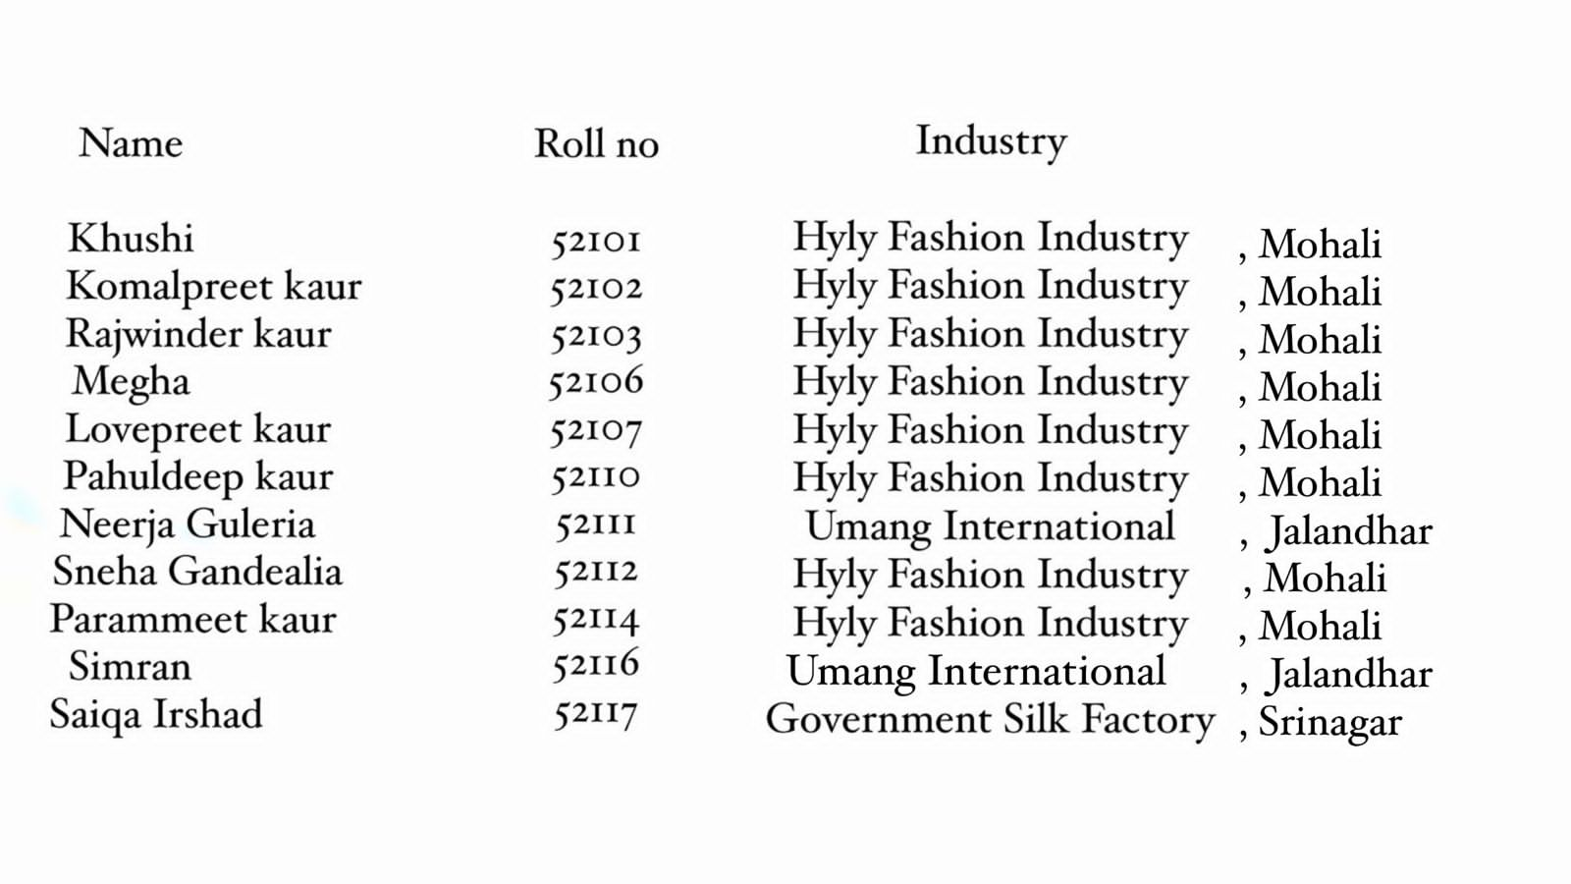

3.Add on course -NIL
4.Students enrolled in add on course -NIL

